L1F23BSSE0372
Muhammad Arham

Question 1
Code
import java.util.Scanner;
public class Q1_Airline_Reservation {
public static void main(String[] args) {
Scanner scanner=new Scanner(System.in);
try{
System.out.print("Enter No Of Seats: ");
int noSeat=scanner.nextInt();
System.out.print("Enter No Of Fare: ");
int totalFare=scanner.nextInt();
int calculate=totalFare/noSeat;
} catch (ArithmeticException e) {
System.out.println("No Of Seat Can't Divide By Zero");
System.out.println("Please Enter A Valid No Of Seats");
}
System.out.println("Program continues running safely...");
}
}

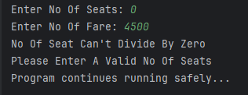
Output

Question 2
Code
import java.util.InputMismatchException;
import java.util.Scanner;
public class Q2_Banking_Loan {
public static void checkLoan(double amount)throws Exception{
Scanner input=new Scanner(System.in);
if (amount<0){
throw new InputMismatchException("Loan Amount Must Be Positive");
}
System.out.println("Loan Amount Approved: "+amount);
}
public static void main(String[] args) {
try {
Scanner input=new Scanner(System.in);
System.out.print("Enter Loan Amount: ");
double amount=input.nextInt();
checkLoan(amount);
}catch (Exception e){
System.out.println(e.getMessage());
System.out.println("Please Enter Valid Amount");
}
}
}

Output
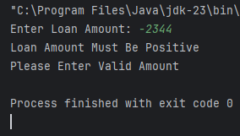
Question 3
Code
import java.util.InputMismatchException;
import java.util.Scanner;
public class Q3_Examination_Portal {
public static void checkMarks(int marks)throws Exception{
Scanner input=new Scanner(System.in);
if (marks>100){
throw new InputMismatchException("Marks Can't Greater Then 100");
}
System.out.println("Your Marks: "+marks);
}
public static void main(String[] args) {
/*An examination portal should not allow marks greater than 100.
Create a custom exception called InvalidScoreException and handle it.*/
try {
Scanner input=new Scanner(System.in);
System.out.print("Enter Marks: ");
int marks=input.nextInt();
checkMarks(marks);
}catch (Exception e){
System.out.println(e.getMessage());
System.out.println("Please Enter Valid Marks");
}
}
}

Output
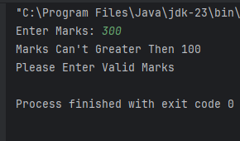
Question 4
Code
import java.util.InputMismatchException;
import java.util.Scanner;
public class Q4_University_Management {
static void addName(String name)throws Exception{
if (name==null){
throw new RuntimeException("Name Can't Null");
}
System.out.println("Teacher Name: "+name);
}
public static void main(String[] args) {
try {
Scanner input = new Scanner(System.in);
System.out.print("Enter Name: ");
String name = input.nextLine();
addName(name);
} catch (Exception e) {
System.out.println(e.getMessage());
}
}
}

Output
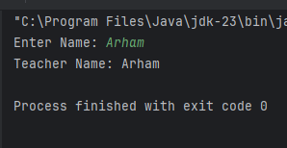
Question 5
Code
import java.util.InputMismatchException;
import java.util.Scanner;
public class Q5_Electricity_Billing {
static void checkElectricityBill(String units) throws InputMismatchException{
if (!units.matches("\\d+")){
throw new InputMismatchException("Error: Please enter numbers only.");
}
System.out.println("Units: "+units);
}
public static void main(String[] args) {
try{
Scanner input=new Scanner(System.in);
System.out.print("Enter Units: ");
String units=input.nextLine();
checkElectricityBill(units);
} catch (InputMismatchException e) {
System.out.println(e.getMessage());
}
}
}

Output
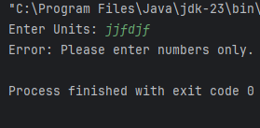

Question 6
Code
public class Q6_Logging_Program {
public static void main(String[] args) {
try {
System.out.println("[DEBUG] Program started");
System.out.println("[WARN] Low memory warning");
throw new Exception("File not found");
} catch (Exception e) {
System.out.println("[ERROR] " + e.getMessage());
}
System.out.println("[DEBUG] Program ended safely");
}
}

Output
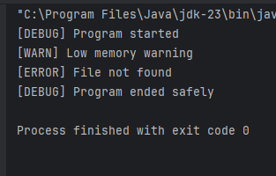
Question 7
Code
public class Q7 {
public static void main(String[] args) {
try {
int a = 15;
int b = 5;
int result = (a / b) + 5;
System.out.println("Division = " + result);
} catch (ArithmeticException e) {
System.out.println("Error: Cannot divide by zero");
}
}
}

Output
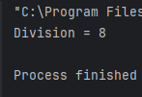
Question 8
Code
public class Q8_Hospital_Logging {
static void updatePatientReport(String patientName) {
try {
System.out.println("[INFO] Doctor started updating report");
System.out.println("[DEBUG] Fetching patient data for: " + patientName);
if (patientName == null) {
throw new NullPointerException("Patient name is missing!");
}
System.out.println("[INFO] Updating medical records...");
System.out.println("[WARN] Ensure all details are verified before saving");
System.out.println("[INFO] Patient report updated successfully");
System.out.println("[DEBUG] Operation completed for: " + patientName);
} catch (NullPointerException e) {
System.out.println("[ERROR] " + e.getMessage());
}
}
public static void main(String[] args) {
updatePatientReport("Ali Khan");
updatePatientReport(null);
}
}

Output
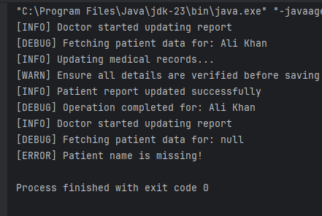
Question 9
Code
public class Q9 {
public static void main(String[] args) {
int m = 4;
int n = m * 3;
int p = n - 5;
System.out.println("p= "+p);
}
}

Output
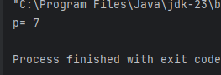
Question 10
Code
public class Q10_Railway_Reservation {
static int maxRetries = 3;
static void bookTicket() throws Exception {
double random = Math.random();
if (random < 0.7) {
throw new Exception("Server connection failed");
}
System.out.println("Ticket booked successfully!");
}
public static void main(String[] args) {
int attempt = 0;
boolean success = false;
while (attempt < maxRetries && !success) {
try {
attempt++;
System.out.println("Attempt " + attempt + " to book ticket...");
bookTicket();
success = true;
} catch (Exception e) {
System.out.println("Error: " + e.getMessage());
if (attempt == maxRetries) {
System.out.println("Booking failed after " + maxRetries + " attempts.");
} else {
System.out.println("Retrying...");
}
}
}
}
}

Output
